Program Data Provider

AWS Cloud Services Onboarding Co-op Students

Version Number: 1.0
Version Date: September 24, 2026
Draft

Business Intelligence Program Data Provider (PDP)
Strategic Services Compliance Data Division (SSCD)
Compliance Management Directorate (CMD)
Information Technology Branch (ITB)
Canada Revenue Agency

Services du programme d’intelligence d’affaires (SPIA)
Division des services stratégiques et des données d’observation (SSDO)
Direction de la gestion de l'observation (DGO)
Direction générale de l'informatique (DGI)
Agence du revenu du Canada

Document Version History
Table 1: Document Version History
Version # | Version Date | Author | Revision Notes
1.0 | September 24, 2026 | Nermeen Mesak | Initial draft

Table of Contents
1 Document Version History 1
2 Document Overview 3
2.1 Effective Date 4
2.2 Purpose 4
2.3 Audience 4
3 Amazon EventBridge 4
3.1 The steps to navigate to Scheduled rules in Amazon EventBridge 4
3.2 EventBridge dev1-kg01-avmt4-adhoc-schedule 6
3.2.1 Rule details 6
3.2.2 Event schedule 6
3.2.3 Targets 7
4 AWS Stepfunction (State machines) 8
4.1 The steps to navigate Stepfunction. 8
4.2 AWS Step Functions state machine Definition 14
4.2.1 Start at NotifyStart 15
4.2.2 NotifyStart - Send a starting notification 15
4.2.3 RunGlueJob - Start the Glue job 16
4.2.4 ReadAndFormatResults - Run Lambda 16
4.2.5 NotifyEnd - Send successful completion notification 18
4.2.6 Path 2: Glue job fails 19
4.2.7 ParseError - Extract error information 20
4.2.8 NotifyFailure - Send failure notification 20

Document Overview

Effective Date
This draft becomes effective when it is approved and published for use.

Purpose
The purpose of this document is to help Co-op students and new developers become familiar with the AWS services, tools, and processes used within the PDP.

This document is intended to:
- Provide an overview of the key AWS services used in PDP.
- Explain the role of each service within the PDP architecture and workflow.
- Help new team members understand how the different AWS services interact with each other.
- Provide practical guidance for navigating and using AWS services during development, deployment, troubleshooting, and testing activities.
- Introduce common PDP processes, such as source deployment, data processing, Data Product creation, subscription, and publishing.
- Serve as a quick reference during onboarding and day-to-day development activities.
- Help new developers gain confidence working within the PDP AWS environment while following the team's established practices.

Audience
The audience for this document includes:
- New PDP developers who are onboarding to the project.
- Co-op students joining the PDP development team.
- Team members who are new to the AWS services and tools used within PDP.
- Developers who need a reference to better understand the PDP AWS environment, services, and development processes.
This document assumes that readers have a basic understanding of software development concepts but may have limited experience with AWS or the PDP environment.

Amazon EventBridge

The steps to navigate to Scheduled rules in Amazon EventBridge
- Log in to the AWS Management Console.
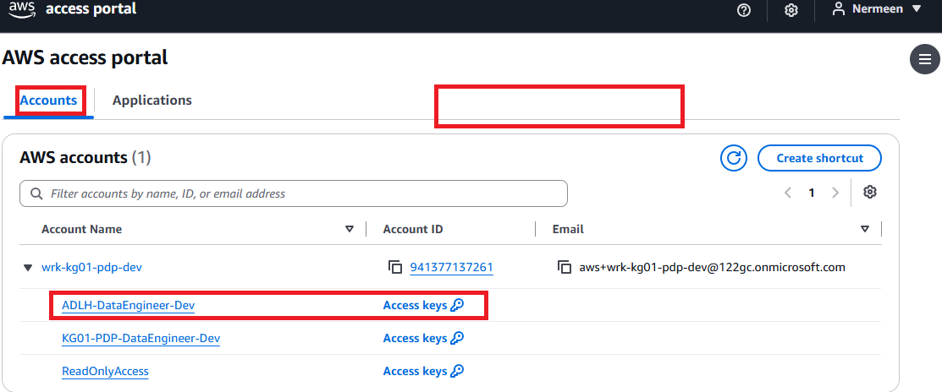
- In the search bar at the top, search for Amazon EventBridge.
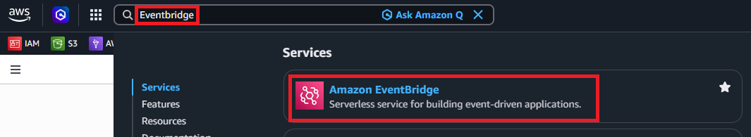
- Select Amazon EventBridge from the results.
- From the left navigation menu, select Scheduler, Scheduled rules legacy.
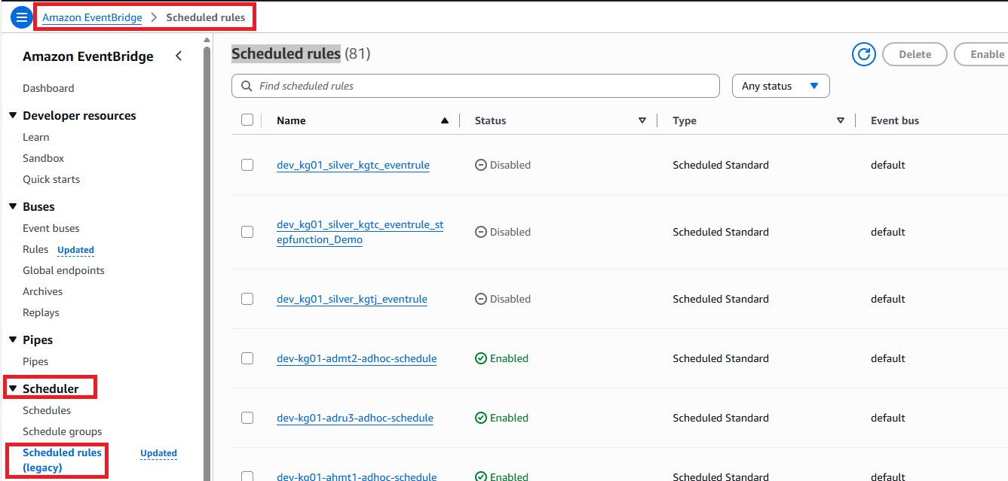
- To view existing EventBridge scheduled rules, in search bar writ AVMT
You see 2 schedules
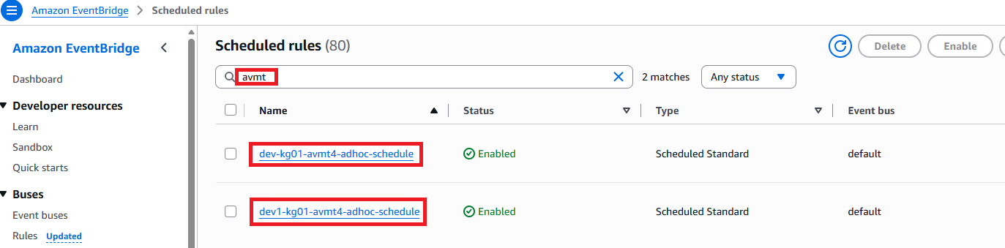
- In Dev Environment, each source DBID has 2 schedules
- Main branch dev-kg01-avmt4-adhoc-schedule.
- Development branch dev1-kg01-avmt4-adhoc-schedule.

EventBridge dev1-kg01-avmt4-adhoc-schedule

Rule details

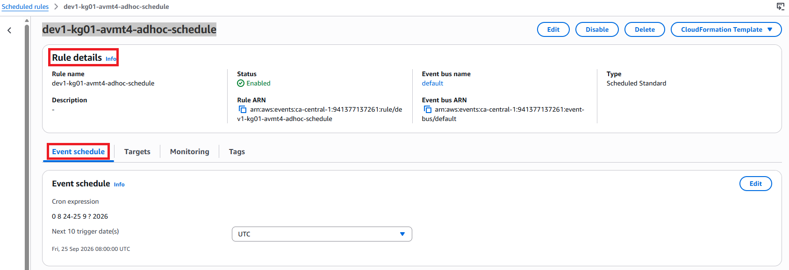
- Rule name: dev1-kg01-avmt4-adhoc-schedule
- Status: Enabled. The scheduled rule is active and can trigger at the configured time.
- Event bus: default
- Type: Scheduled Standard
- Rule ARN: The unique AWS identifier for this EventBridge rule.

Event schedule
The important part is the Cron expression.
AWS EventBridge cron expressions use the following format:
Minutes Hours Day-of-month Month Day-of-week Year
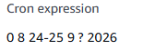
So this expression means:
- 0 → At minute 00
- 8 → At 08:00 UTC
- 24-25 → On September 24 and 25
- 9 → September
- ? → No specific day of the week
- 2026 → Year 2026
Therefore, the rule is scheduled to run at:
- September 24, 2026 at 08:00 UTC
- September 25, 2026 at 08:00 UTC

Targets
The Targets tab identifies what EventBridge invokes when this schedule fires.

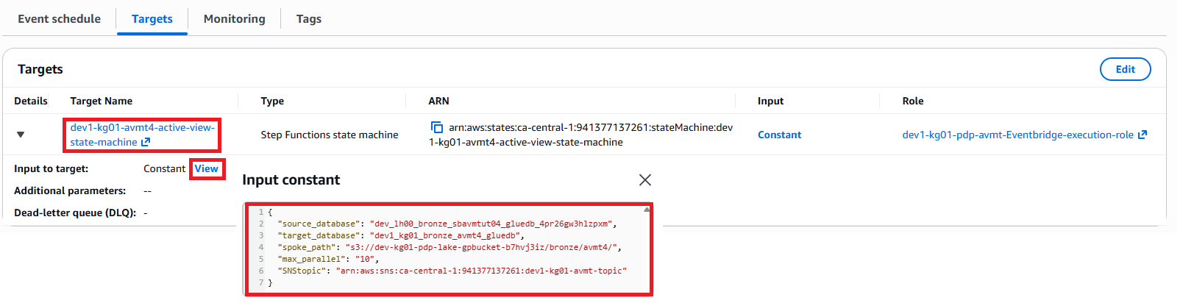
- Target Name: dev1-kg01-avmt4-active-view-state-machine.
- Type: Step Functions state machine.
- Target ARN: Points to the dev1-kg01-avmt4-active-view-state-machine in the ca-central-1 region.
- Input: Constant
EventBridge sends predefined input to the Step Functions state machine each time the rule is triggered.
- Click View beside Constant to see the actual input being passed.
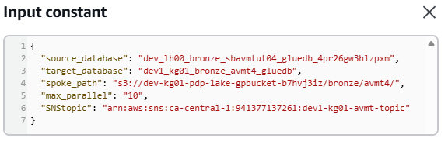
- Role: dev1-kg01-pdp-avmt-Eventbridge-execution-role
This is the IAM role EventBridge uses to get permission to start the Step Functions state machine.
Targets: The Targets tab identifies the AWS resource that is triggered by the scheduled EventBridge rule. In this example, the target is the Step Functions state machine dev1-kg01-avmt4-active-view-state-machine. When the scheduled time is reached, EventBridge uses the configured IAM execution role to invoke the state machine. Select View under Input to review the constant input parameters passed to the state machine.

AWS Stepfunction (State machines)

The steps to navigate Stepfunction.
- Sign in to the AWS Management Console.
- In the search bar at the top of the AWS Console, search for Step Functions.
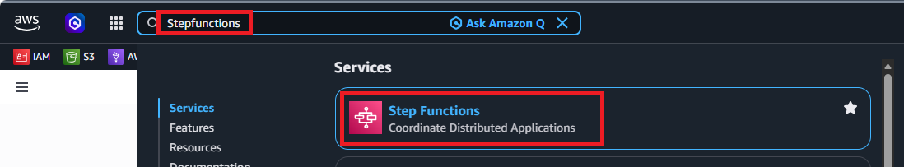
- Select Step Functions from the search results.
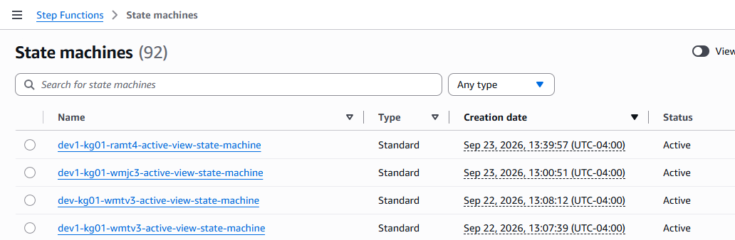

- From the left navigation menu, select State machines. A list of available state machines will be displayed.
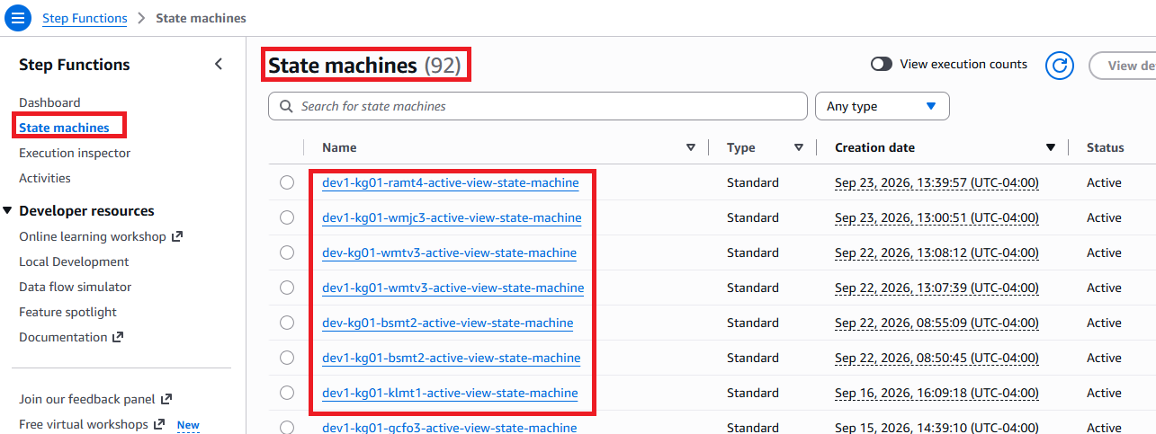

- Search for or select the AVMT4 state machine.
In Dev Environment, each source DBID has 2 state machines.
- Main branch dev-kg01-avmt4-active-view-state-machine.
- Development branch dev1-kg01-avmt4-active-view-state-machine.
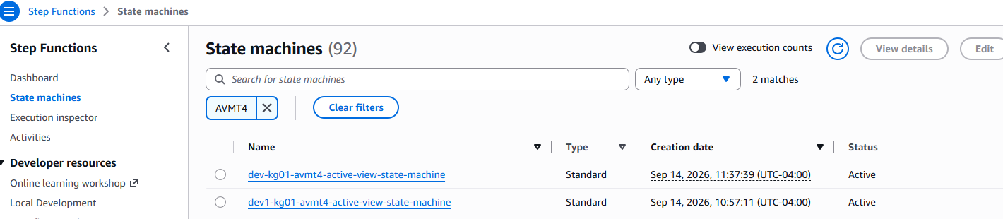
- Select dev1-kg01-avmt4-active-view-state-machine State machine details page will open.
- Arn: arn:aws:states:ca-central-1:941377137261:stateMachine:dev1-kg01-avmt4-active-view-state-machine.
- IAM execution role: dev1-kg01-pdp-avmt-Stepfunction-execution-role
- This is the IAM role that the Step Functions workflow uses when accessing or invoking other AWS resources.
- Type: Standard.
- Status: Active, meaning the state machine is available to run.
- Creation date: September 14, 2026 at 10:57:11, shown in UTC-04:00.
- Region: ca-central-1, based on the ARN.

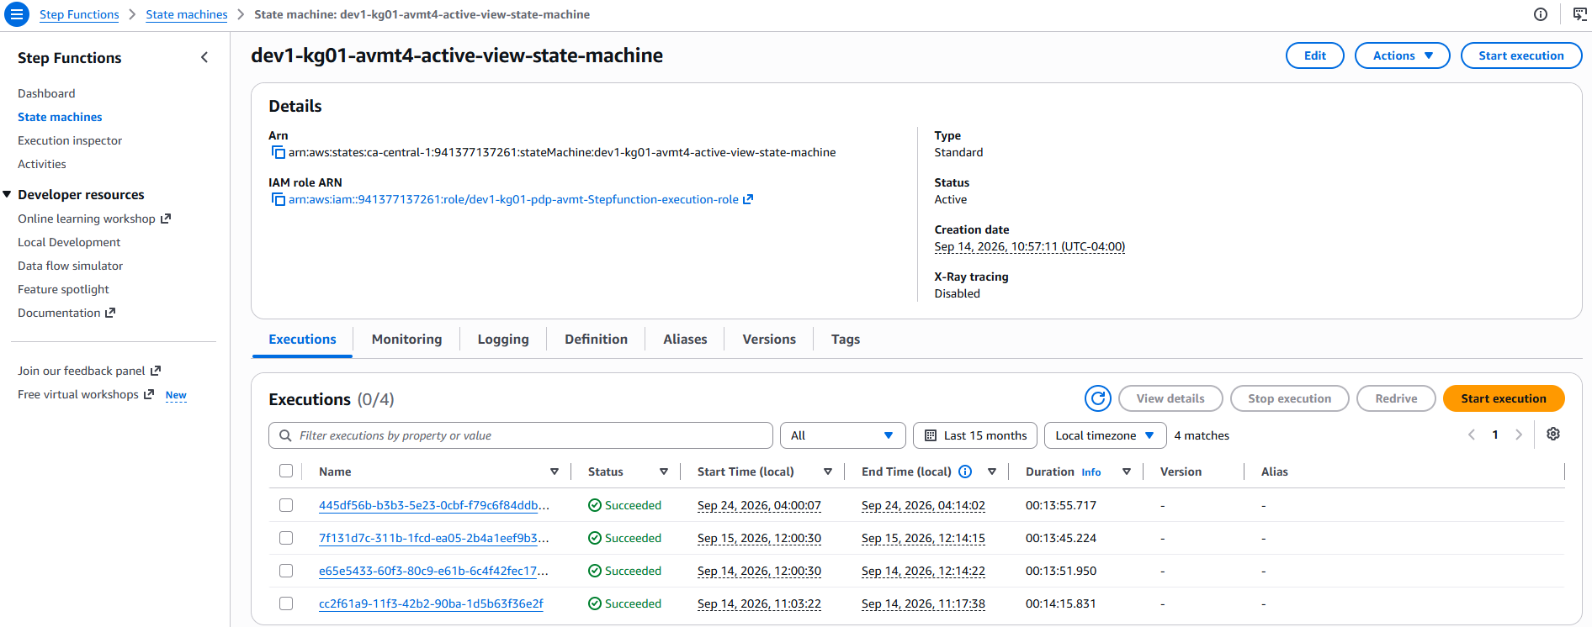

- Select the Executions tab to view previous executions and their status, such as Succeeded, Failed, or Running.
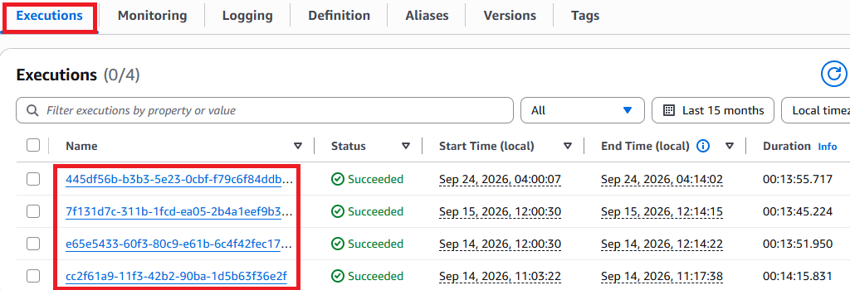

- Select an execution name to viewthe execution details and individual workflow steps.
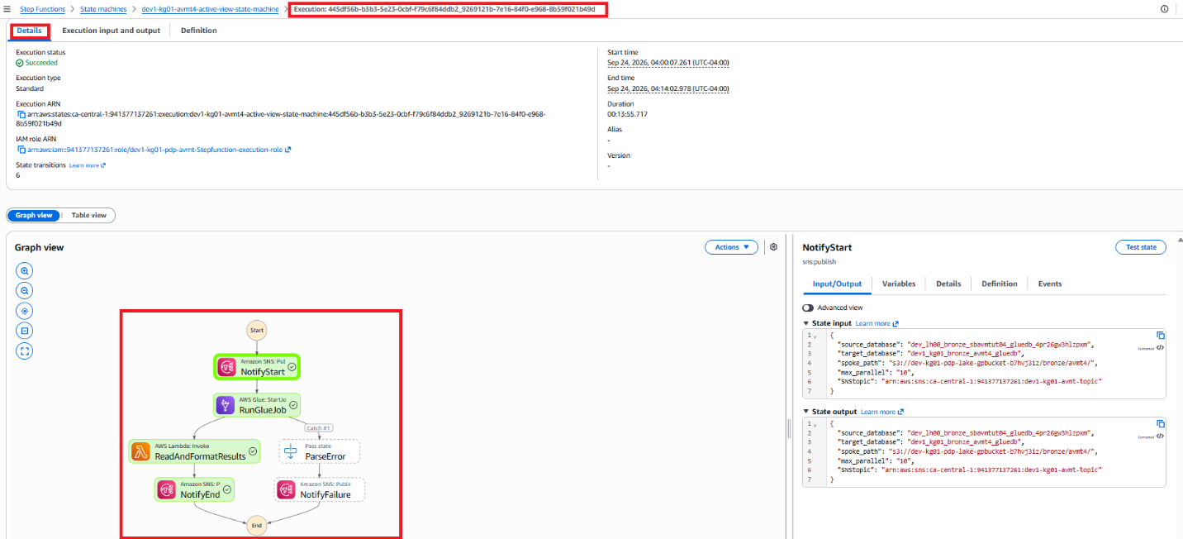
- Execution input and output
Select the Execution input and output tab to review the parameters provided to the Step Functions execution and the results returned during processing. The State input shows values such as the source database, target database, S3 path, maximum parallel processing value, and SNS topic. The State output contains the processing results, including the AWS Glue job details and execution status. This information can be used to verify the execution parameters and troubleshoot processing issues.
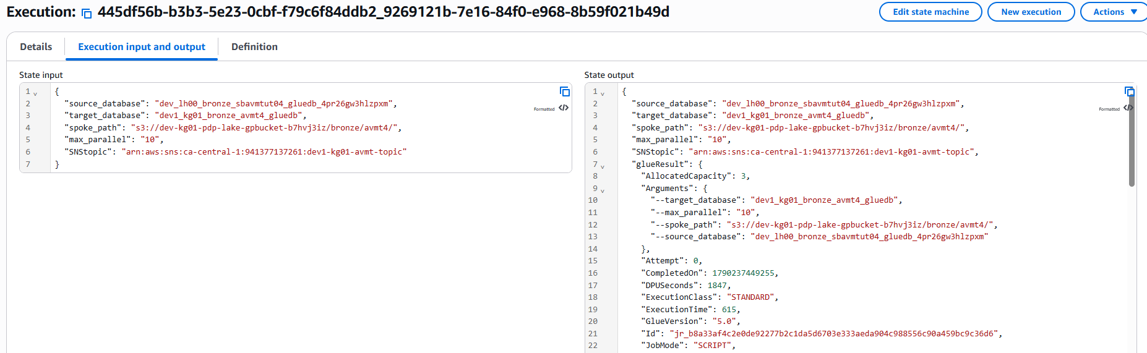
- Select the Definition tab to view the state machine workflow and understand the AWS services and processing steps configured in the state machine.
{
"StartAt": "NotifyStart",
"States": {
"NotifyStart": {
"Type": "Task",
"Resource": "arn:aws:states:::sns:publish",
"ResultPath": null,
"Parameters": {
"TopicArn.$": "$.SNStopic",
"Subject.$": "States.Format('Loading Database {} - Start Notification', $.target_database)",
"Message.$": "States.Format('********************\nStarting\n********************\nDatabase: {}\nStatus: Starting\nTime: {}\n********************', $.target_database, $$.State.EnteredTime)"
},
"Next": "RunGlueJob"
},
"RunGlueJob": {
"Type": "Task",
"Resource": "arn:aws:states:::glue:startJobRun.sync",
"ResultPath": "$.glueResult",
"Parameters": {
"JobName": "dev1-kg01-avmt4-active-view-entire-db-multi-threads-cfn-generated",
"Arguments": {
"--source_database.$": "$.source_database",
"--target_database.$": "$.target_database",
"--spoke_path.$": "$.spoke_path",
"--max_parallel.$": "$.max_parallel"
}
},
"Catch": [
{
"ErrorEquals": [
"States.ALL"
],
"Next": "ParseError",
"ResultPath": "$.glueResult"
}
],
"Next": "ReadAndFormatResults"
},
"ParseError": {
"Type": "Pass",
"Next": "NotifyFailure",
"ResultPath": "$.glueResult",
"Parameters": {
"ParsedCause.$": "States.StringToJson($.glueResult.Cause)",
"ParsedError.$": "$.glueResult.Error"
}
},
"ReadAndFormatResults": {
"Type": "Task",
"Resource": "arn:aws:states:::lambda:invoke",
"ResultPath": "$.lambdaResult",
"Parameters": {
"FunctionName": "arn:aws:lambda:ca-central-1:941377137261:function:dev1-kg01-avmt4-lambda-post-execution-row-counts-cfn",
"Payload": {
"run_id.$": "$.glueResult.Id",
"target_database.$": "$.glueResult.Arguments.--target_database",
"spoke_path.$": "$.glueResult.Arguments.--spoke_path"
}
},
"Retry": [
{
"ErrorEquals": [
"Lambda.ServiceException",
"Lambda.AWSLambdaException",
"Lambda.SdkClientException",
"Lambda.TooManyRequestsException"
],
"IntervalSeconds": 1,
"MaxAttempts": 3,
"BackoffRate": 2,
"JitterStrategy": "FULL"
}
],
"Next": "NotifyEnd"
},
"NotifyEnd": {
"Type": "Task",
"Resource": "arn:aws:states:::sns:publish",
"ResultPath": null,
"Parameters": {
"TopicArn.$": "$.SNStopic",
"Subject": "Glue Job Completed",
"MessageStructure": "json",
"Message": {
"default.$": "$.lambdaResult.Payload.message",
"email.$": "$.lambdaResult.Payload.message"
}
},
"End": true
},
"NotifyFailure": {
"Type": "Task",
"Resource": "arn:aws:states:::sns:publish",
"Parameters": {
"TopicArn.$": "$.SNStopic",
"Subject.$": "States.Format('Glue Job FAILED Database {} - Failure Notification', $.target_database)",
"Message.$": "States.Format('************** GLUE JOB FAILED **************\n\nStatus:\t\t\t{}\nTime:\t\t\t{}\n\n****************** DETAILS *****************\n\n{}\n\nView Glue Job:\nhttps://ca-central-1.console.aws.amazon.com/gluestudio/home?region=ca-central-1#/job/{}/run/{}\n\nView State Machine Execution: \nhttps://ca-central-1.console.aws.amazon.com/states/home?region=ca-central-1#/v2/executions/details/{}\n\n******************************************\n', $.glueResult.ParsedError, $$.State.EnteredTime, $.glueResult.ParsedCause.ErrorMessage, $.glueResult.ParsedCause.JobName, $.glueResult.ParsedCause.Id, $$.Execution.Id)"
},
"End": true,
"ResultPath": null
}
}
}

AWS Step Functions state machine Definition
When the state machine starts, an SNS notification is sent to indicate that processing has begun. The state machine then starts the AWS Glue job and waits for the job to complete. If the Glue job succeeds, a Lambda function processes and formats the post-execution results, including row-count information, and an SNS completion notification is sent. If the Glue job fails, the state machine captures and parses the error information and sends an SNS failure notification containing troubleshooting details and links to the Glue job and Step Functions execution.

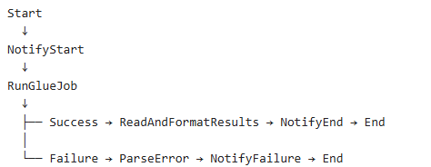

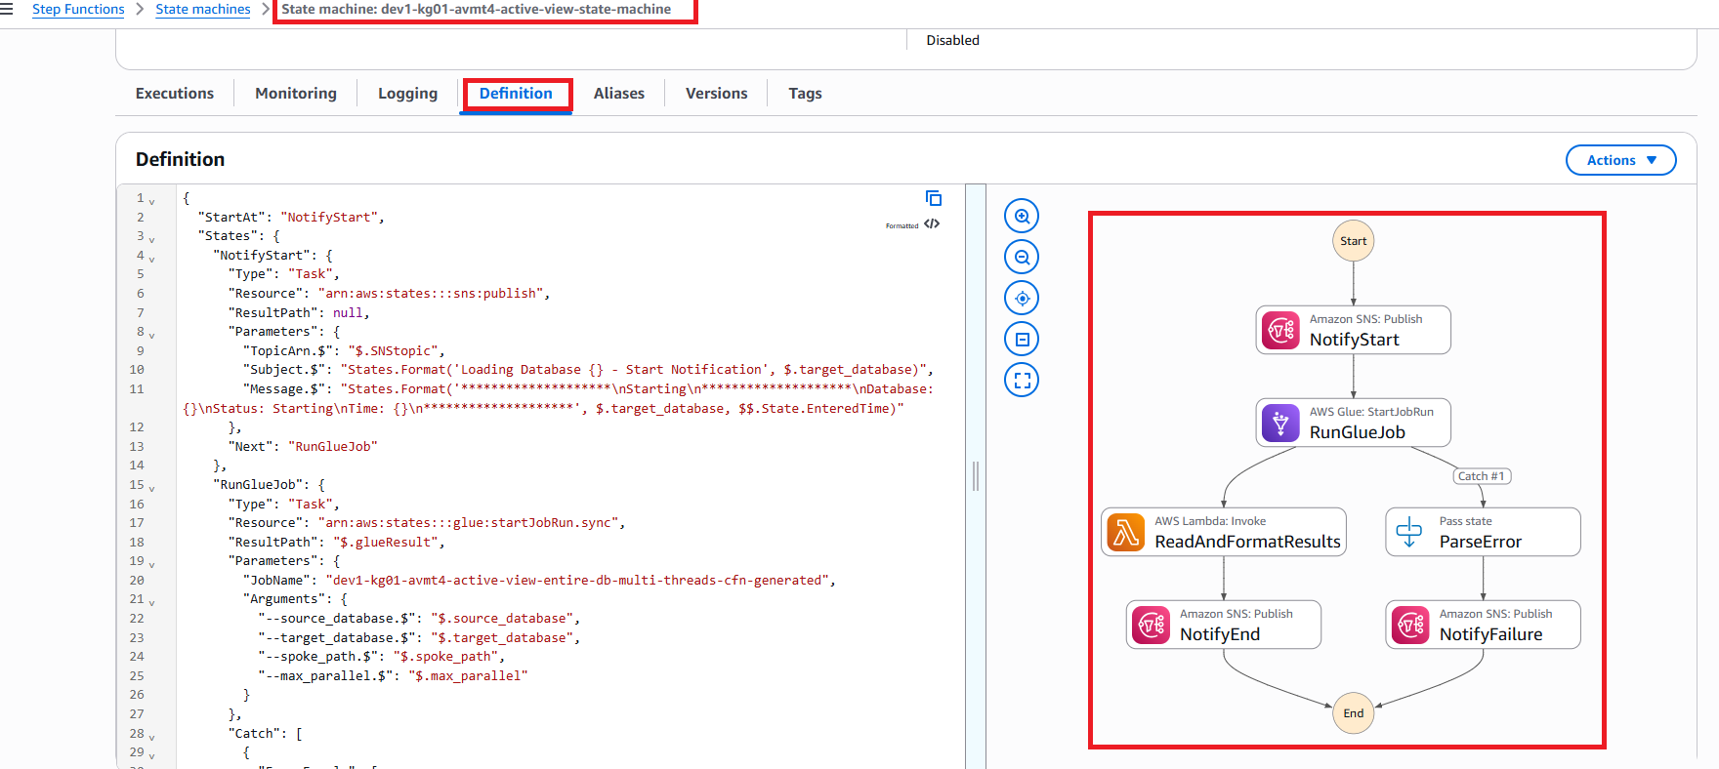

Start at NotifyStart
"StartAt": "NotifyStart"
This tells Step Functions that the first step of the workflow is NotifyStart.

NotifyStart - Send a starting notification
The first task publishes a message to Amazon SNS.
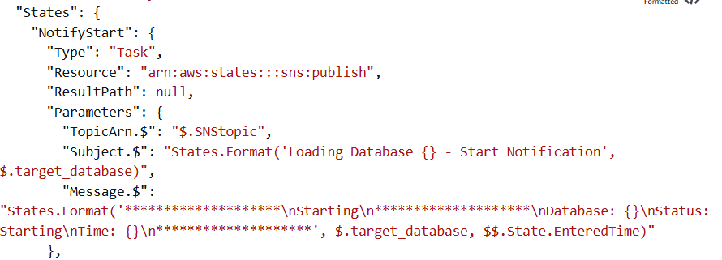
The SNS topic is obtained from: $.SNStopic
The notification subject contains the target database name:
Loading Database <target_database> - Start Notification
The message includes:
- Database name
- Status: Starting
- Time when the Step Functions state was entered
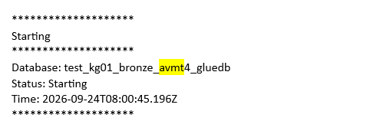
Figure 1: Example Starting email

RunGlueJob - Start the Glue job
The next step starts this AWS Glue job
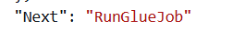
dev1-kg01-avmt4-active-view-entire-db-multi-threads-cfn-generated
The following parameters are passed to the Glue job from the Step Functions input:
- source_database
- target_database
- spoke_path
- max_parallel
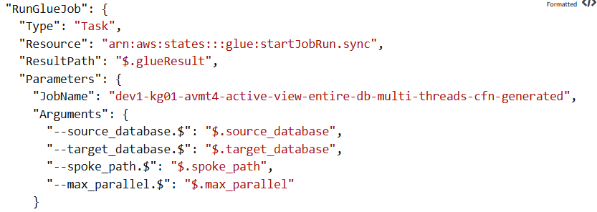
Note: .sync mean
The .sync means Step Functions waits for the Glue job to finish before continuing to the next step.
The Glue job output is stored in: $.glueResult
There are now two possible paths:
Path 1: Glue job succeeds.

ReadAndFormatResults - Run Lambda
After the Glue job succeeds, Step Functions invokes this Lambda function:
dev1-kg01-avmt4-lambda-post-execution-row-counts-cfn
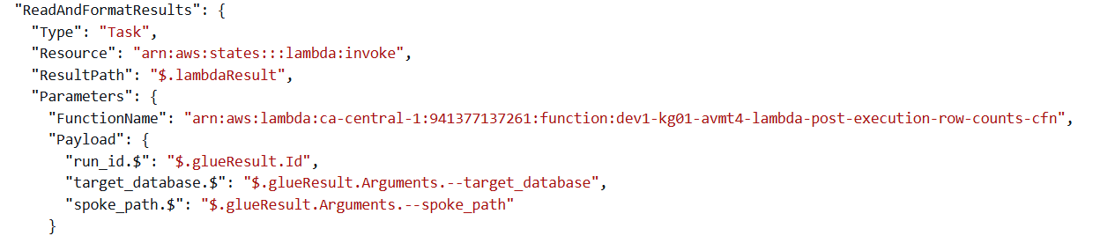The Lambda receives:
- Glue run_id
- target_database
- spoke_path
The purpose is to process the results after the Glue execution, including the post-execution row-count information indicated by the Lambda name.
The Lambda result is saved in: $.lambdaResult

Lambda retry
If the Lambda invocation encounters a temporary AWS service, SDK, or throttling error, Step Functions automatically retries the task. The retry interval starts at 1 second and increases using a backoff rate of 2. A full jitter strategy adds randomness to the retry delay to help reduce repeated throttling. The task can be retried up to three times before the execution proceeds according to its failure handling configuration.

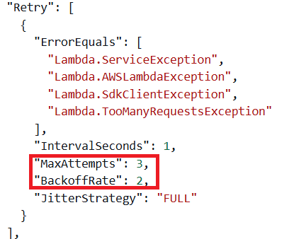
If Lambda temporarily fails because of certain AWS service errors, Step Functions automatically retries. It can retry up to 3 attempts

ErrorEquals
This specifies which errors should trigger a retry:
- Lambda.ServiceException - A Lambda service-side error occurred.
- Lambda.AWSLambdaException - An error occurred while Step Functions was communicating with Lambda.
- Lambda.SdkClientException - The AWS SDK encountered a client/communication problem.
- Lambda.TooManyRequestsException - Lambda is being throttled because too many requests are being made.

IntervalSeconds
The first retry starts with a 1-second retry interval. "IntervalSeconds": 1

MaxAttempts
Step Functions can retry the failed Lambda task up to 3 times under this retry policy.

BackoffRate
The wait time increases by a factor of 2 after each retry.
Conceptually, the retry delays grow like: "BackoffRate": 2
First retry → approximately 1 second
Second retry → approximately 2 seconds
Third retry → approximately 4 seconds
This helps handle temporary Lambda/AWS service issues.

JitterStrategy
Because JitterStrategy is enabled, the actual delays can vary rather than always being exactly 1, 2, and 4 seconds. This adds randomness to the retry delay.
The purpose is to prevent many requests from retrying at exactly the same time, which can be especially useful when Lambda is being throttled.

NotifyEnd - Send successful completion notification
After Lambda completes, Step Functions sends another SNS notification.
The subject is: Glue Job Completed
The message comes from: $.lambdaResult.Payload.message
So the Lambda function prepares the final message, and SNS sends that message to the configured recipients.
After this: "End": true

Path 2: Glue job fails
The workflow also has error handling. Inside RunGlueJob, there is:
Instead of immediately ending the state machine, Step Functions goes to: ParseError

ParseError - Extract error information
ParseError processes the error returned from the failed Glue job.
It extracts:
- The error type
- Error cause
- Error message
- Glue job information
The parsed information is put back into: $.glueResult
This makes the failure information easier for the next step to use.

NotifyFailure - Send failure notification
Finally, Step Functions publishes an SNS failure notification.
The subject looks like: Glue Job FAILED Database <target_database> - Failure Notification
The message contains useful troubleshooting information, including:
- Failure status
- Failure time
- Error message
- Glue job name
- Glue job run ID
- Link to the Glue job execution
- Link to the Step Functions execution
After the notification is sent: "End": true. The workflow finishes.

Damilola

S3 Bucket

AWS Athena

AWS Glue Job and Database

Youssef

AWS SNS

AWS Lambda

AWS LakeFormation

IAM Roles

